**Kala Kendra -C2C art expo**

**MINI-PROJECT REPORT**

Submitted in partial fulfillment of the requirements of the degree

**BACHELOR OF ENGINEERING IN**

**INFORMATION TECHNOLOGY**

By

DHRUV BHARWADA - 08

ADITYA BHAT - 09

SHRUTIK GUPTA - 32

KRUSHANG KADAKIA - 46

Guide

### Prof. Sampada Pinge

### 

Department of Information Technology

**Thadomal Shahani Engineering College**

Adv. Nari Gursahani Marg, TPS III, Off Linking Rd, Bandra West,

Mumbai, Maharashtra 400050



**University of Mumbai**

(Academic Year 2024-25)

# CERTIFICATE

This is to certify that the Mini Project entitled **“Kala Kendra – C2C art expo”** is a bonafide work of **Dhruv Bharwada (08), Aditya Bhat (09), Shrutik Gupta (32), Krushang Kadakia (46)** submitted to the University of Mumbai in partial fulfillment of the requirement for the award of the degree of **“Bachelor of Engineering”** in **“Information Technology Engineering”.**

#### Prof. Sampada Pinge Prof. G. T. Thampi

Project Guide Principal

#### Dr. Mukesh Israni HOD

# Mini Project Approval

This Mini Project entitled **“Kala Kendra – C2C art expo”** by **Dhruv Bharwada (08), Aditya Bhat (09), Shrutik Gupta (32), Krushang Kadakia (46)** is approved for the degree of **Bachelor of Engineering** in **Information Technology Engineering.**

**Examiners**

**1………………………………………**

Prof. Sampada Pinge

#### 2…………………………………………

(External Examiner)

Date: October 17, 2024

Place: Mumbai

## ACKNOWLEDGEMENT

This project has consumed a significant amount of time and resources, and we would like to thank everyone who has contributed to its success. We would like to express our deepest gratitude to the project head, **Prof. Sampada Pinge** for histime, patience and direction, as well as for inspiring us throughout. Without their guidance and support, this project would not have been possible. Their expertise, insights, and encouragement were invaluable in helping us navigate the various challenges and complexities of this project.

We would also like to extend our sincere thanks to the many research papers that we consulted throughout the course of this project. The insights and ideas presented in these papers were instrumental in helping us develop a deeper understanding of the subject matter and in shaping the direction of our research.

We are also grateful to our colleagues and friends who provided us with valuable feedback and support throughout the project. Their encouragement and insights were invaluable in helping us refine our ideas and in pushing us to achieve our best work.  
  
The team consisted of the following members:  
Dhruv Bharwada – 08  
Aditya Bhat – 09  
Shrutik Gupta – 32  
Krushang Kadakia – 46.

**ABSTRACT**

“**Kalakendra**” is a cutting-edge, consumer-to-consumer (C2C) art expo website developed using the MERN (MongoDB, Express.js, React, Node.js) stack. This online marketplace serves as a platform for artists to showcase their work and for buyers to explore and purchase a wide range of art across different categories. Kalakendra bridges the gap between creators and collectors, fostering a dynamic and inclusive art community through technology-driven solutions.

The platform offers a wide range of features to facilitate a seamless user experience and cater to the needs of both artists and buyers:

1. **Products, Wishlist, and Cart Functionality:**
   * Users can explore various art products listed by sellers, with an intuitive interface that allows them to view detailed product information.
   * The wishlist feature helps users save their favorite artworks for future consideration, while the cart functionality ensures a streamlined checkout process for purchasing art pieces.
2. **Multilingual Support:**
   * Kalakendra offers a multilingual interface, enabling users to interact with the platform in their preferred language. Currently, the platform supports multiple languages, ensuring accessibility for users across different linguistic backgrounds and expanding its reach to a diverse, global audience.
3. **AI-powered Voice Navigation in Hindi and English:**
   * To enhance the browsing experience, Kalakendra integrates AI-driven voice navigation. Users can easily navigate the platform, search for products, and manage their accounts through voice commands in both Hindi and English, making the platform accessible to a broader range of users and improving the overall usability, particularly for those less familiar with traditional interfaces.
4. **Admin Dashboard:**
   * The platform includes a comprehensive admin dashboard, enabling administrators to manage product listings, monitor user activity, and oversee their products. This feature enhances operational efficiency by providing real-time insights into the platform’s performance and user engagement.

Kalakendra is designed to be intuitive and inclusive, offering a comprehensive platform where artists and buyers can collaborate and engage in a thriving online art community.

# Contents

# Chapter 1 Page No

* 1. Introduction 1
  2. Motivation 1
  3. Problem Statement & Objectives 2
  4. Organization of the Report 3

#### Chapter 2

* 1. Survey of Existing System 4
  2. Limitation Existing system or research gap 4
  3. Mini Project Contribution 5

#### Chapter 3

* 1. Proposed System 6
  2. Architecture/ Framework 7
  3. User Flow 8
  4. Database Structure 9
  5. Results 10
  6. Conclusion and Future work 16
  7. References 17

|  |  |
| --- | --- |
| **List of figures** |  |

### 

|  |  |  |
| --- | --- | --- |
| Fig No. | Title | Page No. |
| 3.4.1 | Orders DB | 9 |
| 3.4.2 | Producsts DB | 9 |
| 3.5.1 | Launch page | 10 |
| 3.5.2 | Registration page | 11 |
| 3.5.3 | Login page | 11 |
| 3.5.4.1 | User dashboard | 12 |
| 3.5.4.2 | Wishlist | 12 |
| 3.5.4.3 | Cart | 12 |
| 3.5.4.4 | Profile | 13 |
| 3.5.5.1 | Admin dashboard | 13 |
| 3.5.5.2 | Orders | 14 |
| 3.5.5.3 | Inventory | 14 |
| 3.5.5.4 | Add product | 15 |
| 3.5.6 | Voice assistant | 15 |

**CHAPTER 1**

* 1. **Introduction**

In today’s digital age, connecting creators and consumers seamlessly is key to fostering growth in online marketplaces. Enter Kalakendra, a C2C platform that brings artists and buyers together in an intuitive, multilingual environment. Kalakendra offers an engaging marketplace where users can explore art, add items to their wishlist or cart, and navigate effortlessly using AI-powered voice commands in Hindi and English.

With features like an admin dashboard for easy management and multilingual support, **Kalakendra** goes beyond traditional art platforms by making the buying and selling experience simple, interactive, and user-friendly. It’s more than a marketplace—it’s a community where creativity thrives and technology enables boundless possibilities for artists and art lovers alike.

### Motivation

### In the world of art, enabling creators and buyers to connect effortlessly is crucial for fostering creativity and ensuring access to diverse artistic expressions. However, many artists struggle to reach a broad audience and sell their work, while buyers face challenges in discovering unique art pieces in a streamlined and personalized way. Without an effective platform, both creators and art enthusiasts are limited in their ability to engage in meaningful transactions and interactions.

### This is where Kalakendra comes in. By offering an inclusive, user-friendly platform designed specifically for art transactions, Kalakendra redefines how art is bought and sold online. Kalakendra empowers both artists and buyers to connect, collaborate, and engage like never before. Through Kalakendra, the boundaries between art creators and collectors are dissolved, enabling a thriving, vibrant art community where creativity and commerce can flourish hand-in-hand.

### Problem statement and objectives

### In response to the challenges faced by artists and buyers in the online art marketplace, we aim to develop Kalakendra, a comprehensive C2C platform that bridges the gap between creators and consumers. The problem at hand is the lack of a seamless, user-friendly, and multilingual platform where artists can easily showcase their work and buyers can conveniently explore, purchase, and engage with art. Without an effective digital solution, artists struggle to reach a wide audience, and buyers face limitations in discovering unique art pieces in a personalized, interactive way.

### Kalakendra seeks to address these challenges by offering a suite of features designed to promote easy transactions, intuitive browsing, and efficient management. Our objectives include developing a platform that enables users to explore various art products, manage their wishlist and cart, and navigate through AI-powered voice commands in both Hindi and English. Additionally, Kalakendra will provide a robust admin dashboard for efficient oversight of marketplace operations, ensuring seamless functionality for sellers and buyers. By providing these features, we aim to empower artists and buyers to connect and collaborate effortlessly, creating a vibrant and inclusive online art community.

### Objectives

* Develop a user-friendly marketplace platform connecting artists and buyers.
* Enable intuitive browsing and product management through wishlist and cart functionality.
* Implement AI-powered voice navigation in Hindi and English for enhanced user interaction and Provide multilingual support to cater to a diverse user base.
* Design an admin dashboard for efficient marketplace management and oversight.
* Foster a community where artists can showcase their work and buyers can engage in seamless transactions.

### Organization of the report

### This report is divided into three chapters. The first chapter covers the project's introduction, problem description, motivation for the topic, and objectives. The second chapter is a review of the literature. It contains all of the research effort done on this topic. This chapter covers all you need to know about studying current systems and learning new technologies. The third chapter describes the suggested system that will be employed in this project. This chapter contains screenshots of the project's block diagram, methodologies, hardware, and software. All materials referred and utilized in the development of this project are included in the references section.

### CHAPTER 2

* 1. **Survey of existing system**

Kalakendra is a specialized C2C platform designed exclusively for the art marketplace, distinguishing it from more general e-commerce platforms such as Etsy or eBay. While these broader platforms serve multiple categories of goods, Kalakendra focuses specifically on empowering artists and buyers within the art community. It offers features tailored to the unique needs of art transactions, such as AI-powered voice navigation, multilingual support, and a dedicated admin dashboard for efficient management of art listings.

Unlike general e-commerce systems, Kalakendra emphasizes the creation of an inclusive and interactive art marketplace. It not only facilitates transactions but also promotes a vibrant community where artists can showcase their work and buyers can discover unique pieces with ease. By providing specialized tools for seamless product browsing, wishlist management, and intuitive communication, Kalakendra addresses the distinct needs of the art industry, offering an optimized and personalized platform for both creators and consumers.

### Limitation of existing system or research gap

### Platforms like Etsy and eBay offer basic marketplace features but lack the specialized tools needed for art transactions, such as multilingual support and AI-powered navigation. Additionally, these platforms don't provide tailored experiences like order tracking or community-building features for artists and buyers.

### Kalakendra fills this gap by offering a dedicated C2C marketplace for art with multilingual support, AI-powered voice navigation, and a profile section for tracking previous orders, delivering a more personalized and intuitive experience.

### 

### Mini project contribution

**Kalakendra** is a user-friendly C2C platform designed specifically for the art community, enhancing interaction between artists and buyers. It facilitates seamless communication and engagement through features such as AI-powered voice navigation and multilingual support, creating a vibrant marketplace for art transactions. Additionally, **Kalakendra** includes functionalities like a profile section for tracking previous orders and wishlist management, empowering users to discover and purchase art more intuitively. This approach transforms the online art buying experience, fostering a dynamic environment where creativity and commerce thrive.

### CHAPTER 3

* 1. **Proposed system**

**Kalakendra** is a user-friendly C2C platform designed to enhance the art marketplace experience for both artists and buyers. It offers a variety of features to improve engagement, accessibility, and overall user satisfaction.

**Features Available to Users:**

* **Profile Management:**  
  Users can track their previous orders, ensuring transparency and enhancing the overall buying experience.
* **Add Art:**  
  Users can register themselves as artists on the platform, providing them with unique login credentials. Artists can update their profiles and manage their art listings as needed.
* **AI-Powered Voice Navigation:**  
  The platform features AI-driven voice navigation in both Hindi and English, enabling users to explore art products and navigate the site intuitively.
* **Wishlist and Cart Management:**  
  Users can easily save their favorite artworks to a wishlist and manage their shopping cart for a smooth purchasing process.

These features collectively create a dynamic and interactive environment for art transactions, fostering a thriving community where creativity and commerce can flourish.

### Architecture / Framework

**Node.js and Express:**  
 Kalakendra leverages Node.js as its server-side runtime environment, allowing for efficient handling of multiple requests simultaneously due to its non-blocking architecture. Express, a minimalist web framework for Node.js, simplifies the process of building robust APIs and facilitates seamless communication between the frontend and backend. Together, they provide a solid foundation for developing a scalable and high-performance application.

**React:**  
 The frontend of Kalakendra is developed using React, a popular JavaScript library for building user interfaces. React enables the creation of interactive and dynamic web applications through its component-based architecture, promoting reusability and maintainability. With React, users can enjoy a responsive and engaging interface, enhancing their overall experience while navigating the platform.

**Firestore:**  
 For database management, Kalakendra utilizes Firestore, a flexible, scalable NoSQL database from Firebase. Firestore's real-time data synchronization capabilities ensure that users have access to the latest information without the need for manual refreshes. Its document-based model allows for easy storage and retrieval of user profiles, art listings, and transaction histories, supporting the collaborative nature of the platform. Firestore’s built-in security features and seamless integration with the Firebase ecosystem enhance the reliability and security of Kalakendra

### User Flow

#### Launch Page: Users are welcomed with a launch page featuring a loading frame. Upon completion of the loading process, they are redirected to the login page.

#### Login and Registration:

#### Login: Users log in using their username and password.

#### Registration: New users can create an account by providing their name, surname, username, security questions, and password.

#### Dashboard: After successfully logging in, users are directed to the dashboard, which presents different options based on their user type:

#### Normal Users:

#### Product Page: View available artworks with detailed descriptions, images, and pricing.

#### Wishlist: Save favorite art pieces for future consideration.

#### Add to Cart: Easily add items for streamlined checkout.

#### Profile Section: Access and manage previous orders for easy tracking.

#### Artists (Admin Dashboard):

#### Analytics Dashboard: Track sales performance and user engagement.

#### Orders Management: View and process incoming orders efficiently.

#### Inventory Management: Manage inventory levels and add new artworks.

#### Art Listing Page: Create, edit, and remove art listings to showcase their portfolio.

### DATABASE STRUCTURE

### 

### 3.4.1 Orders Database

### 

### 3.4.2 Product Database

### RESULTS

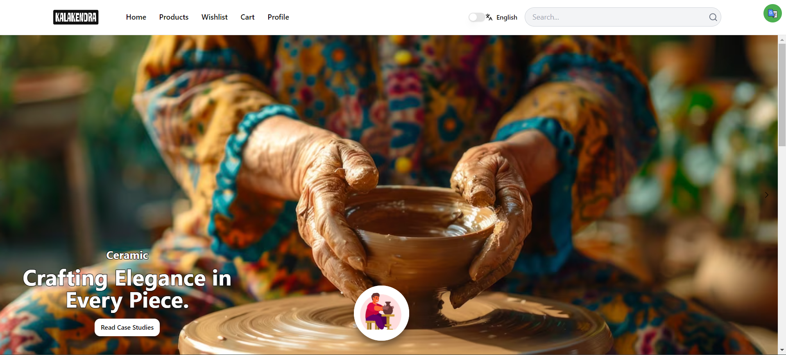

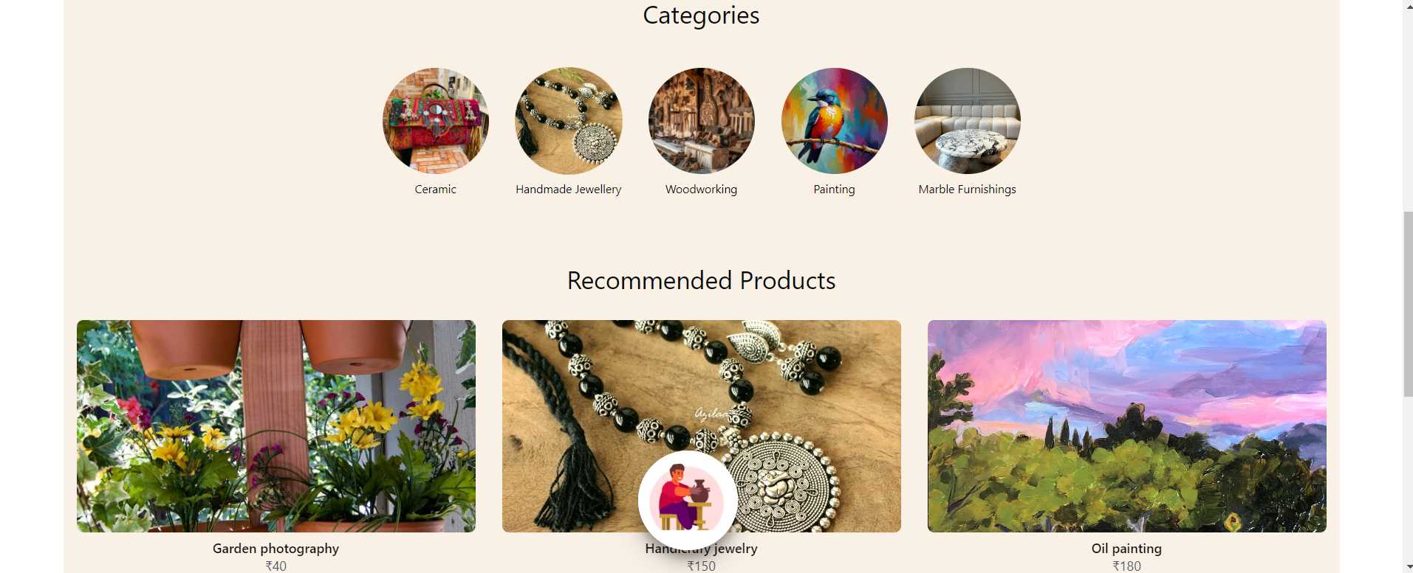

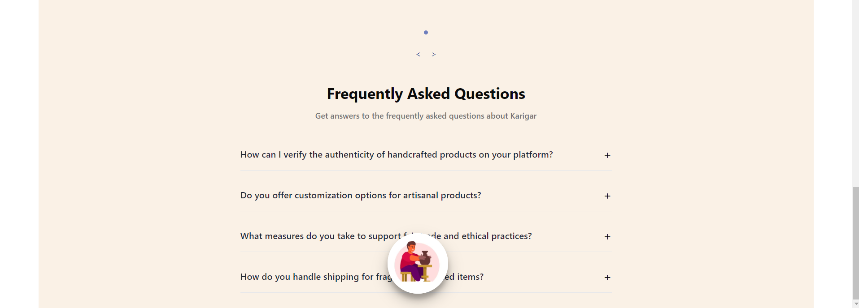

* + 1. Launch page

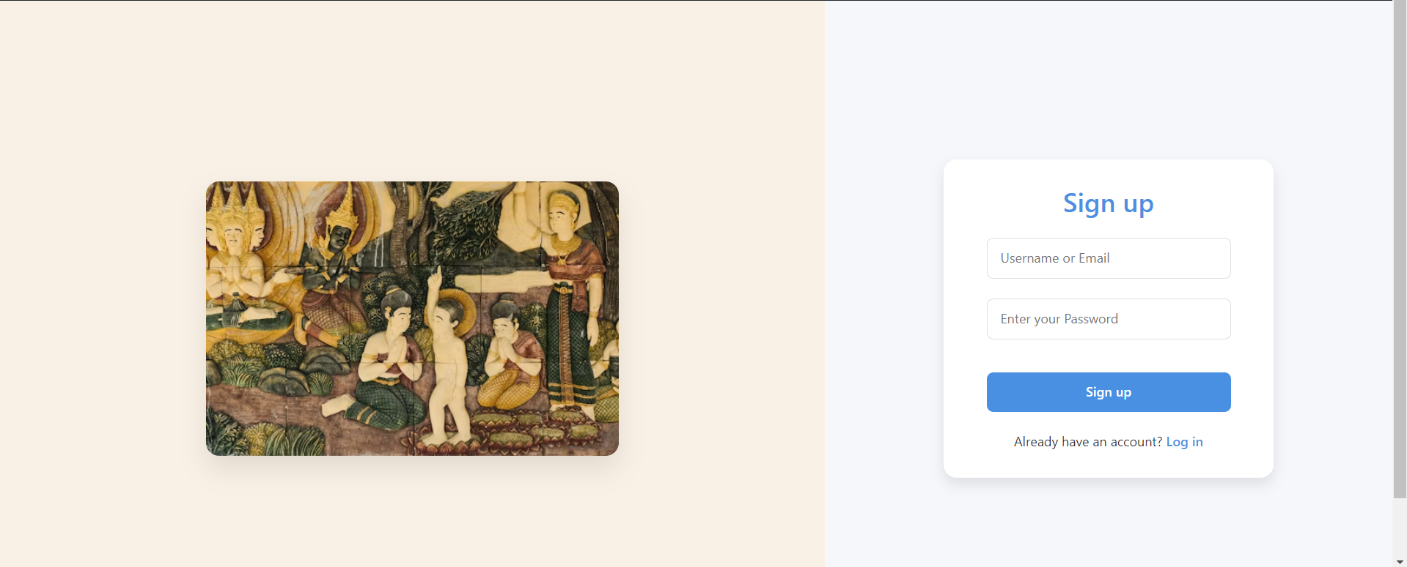

* + 1. Registration Page

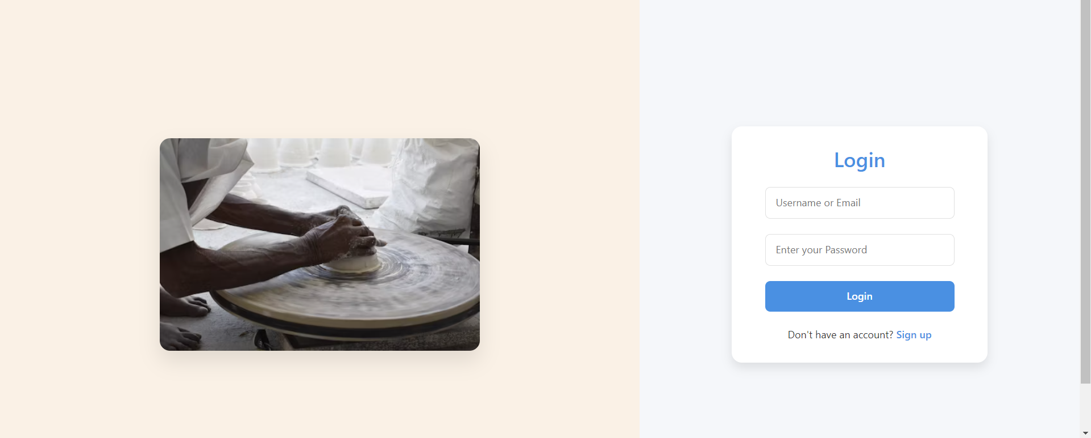

* + 1. Login Page

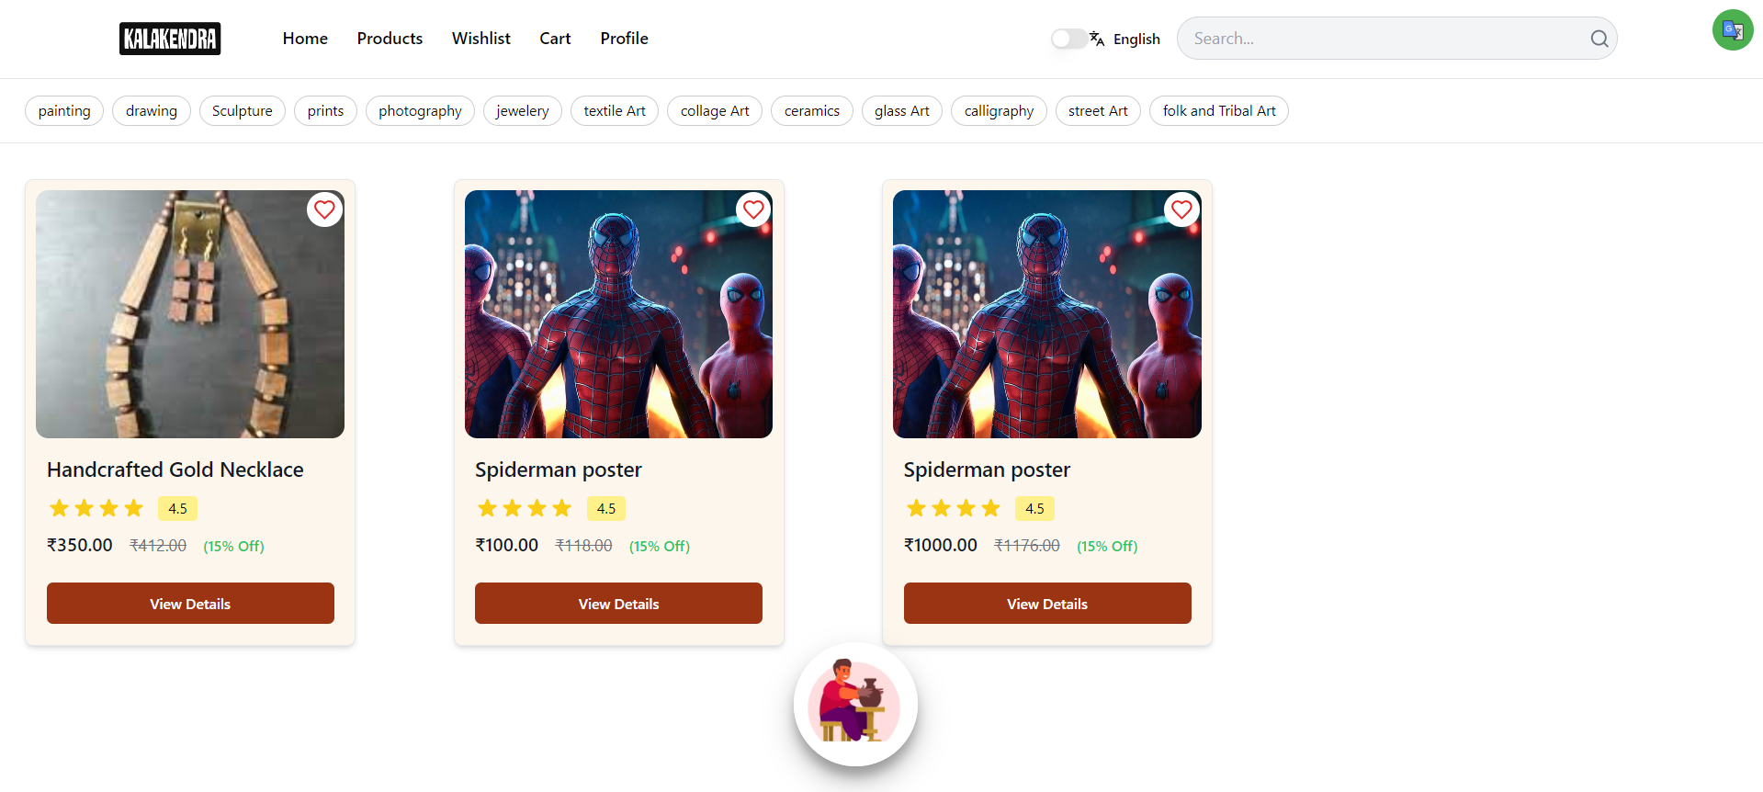

* + - 1. User Dashboard



**3.5.4.2** Wishlist

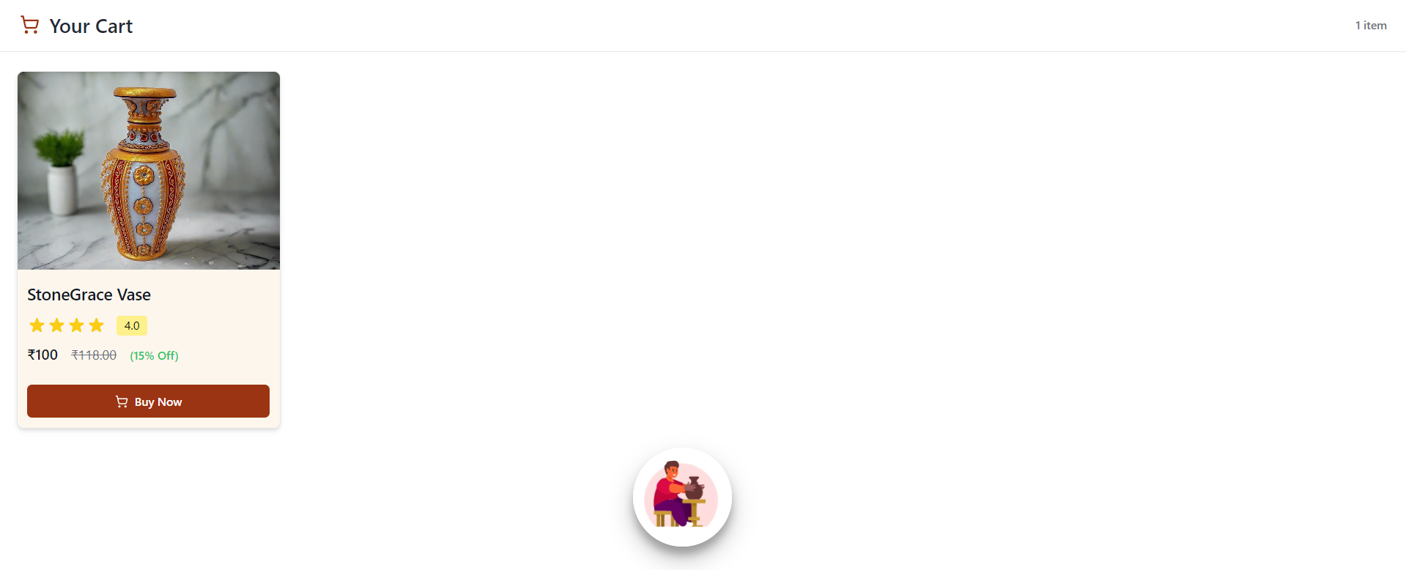

**3.5.4.3** Cart

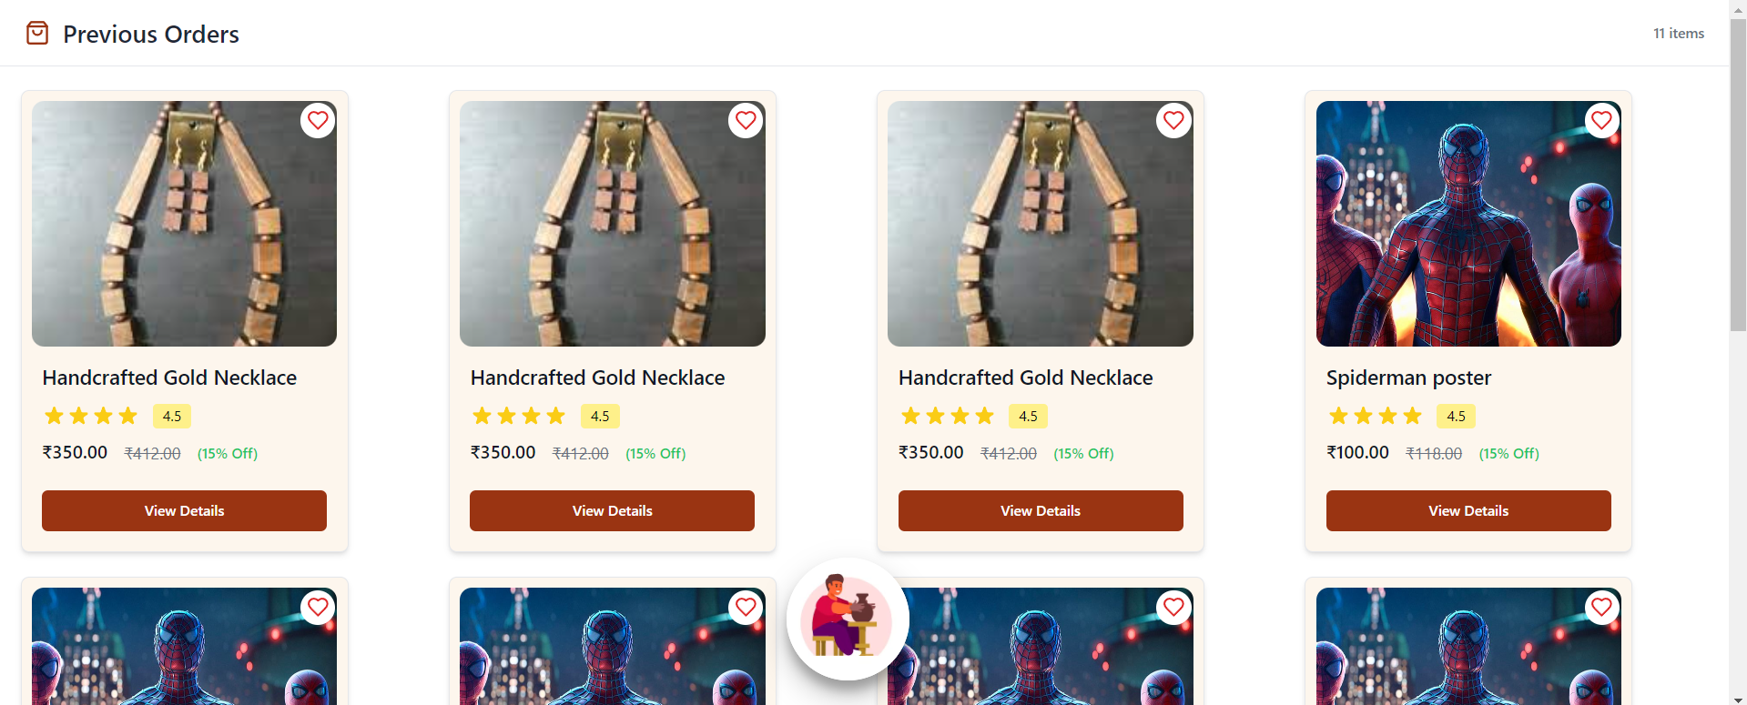

**3.5.4.4** Profile (Previous orders)

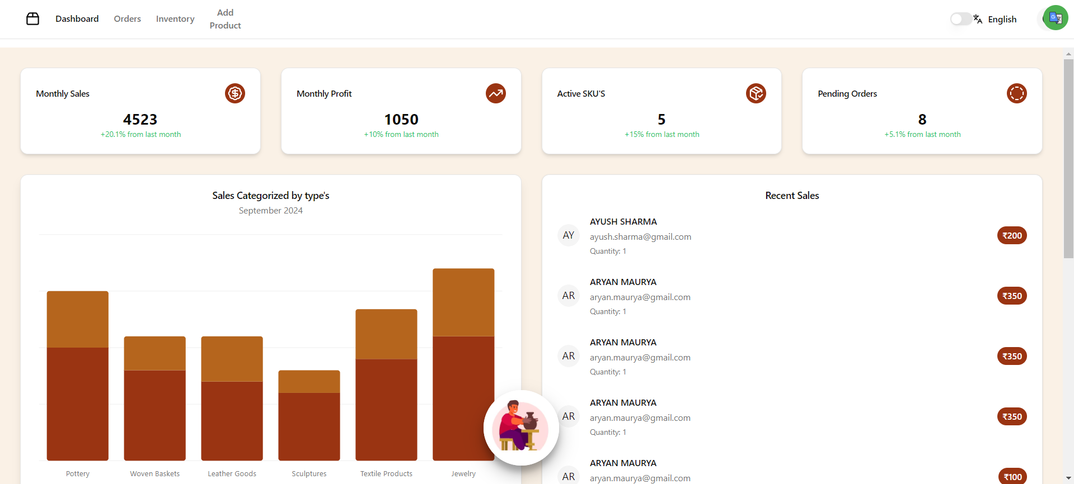

**3.5.5.1** Admin dashboard

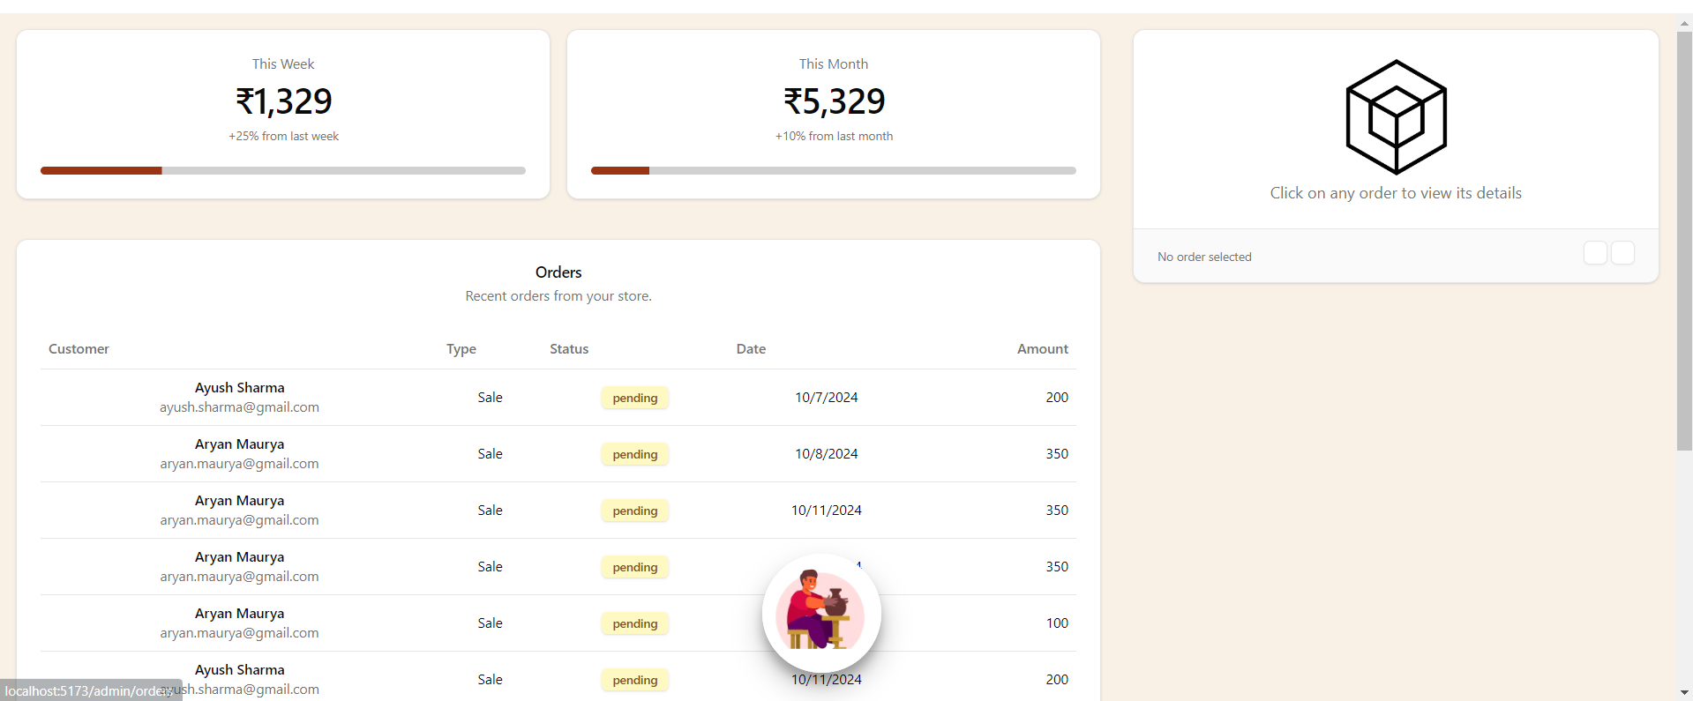

**3.5.5.2** Orders

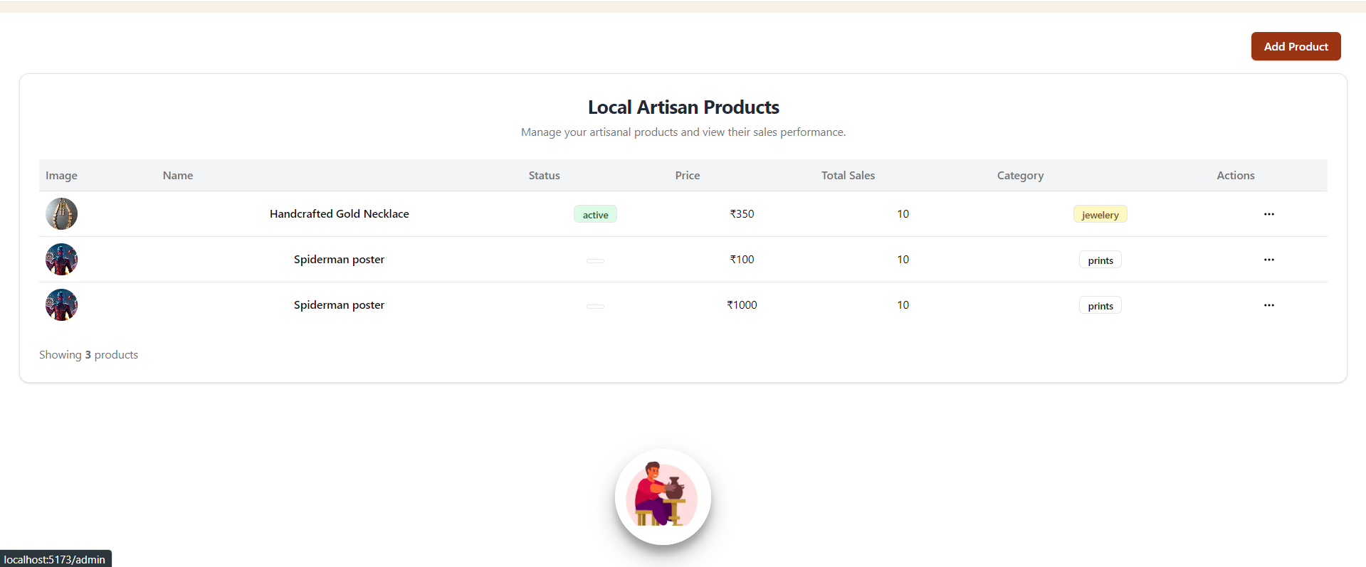

**3.5.5.3** Inventory

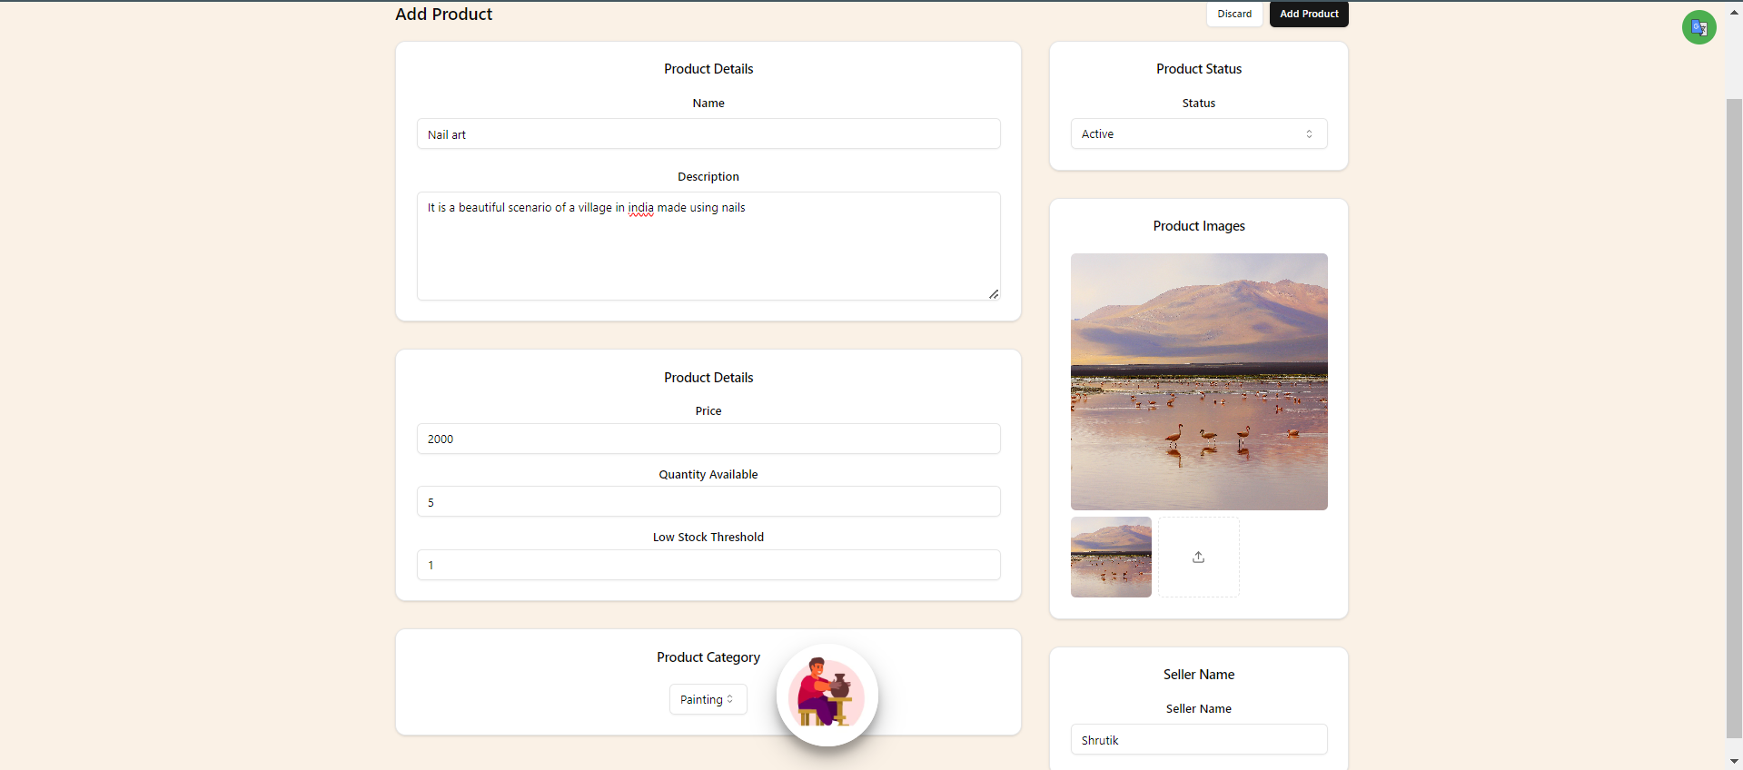

**3.5.5.4** Add product

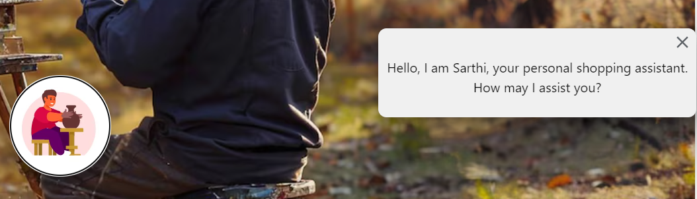

**3.5.6** Voice assistant

### 3.6 CONCLUSION AND FUTURE WORK

In conclusion, Kalakendra represents a transformative online marketplace that revolutionizes the art buying and selling experience. With features like user profile management, wishlist functionality, an interactive product display, and an admin dashboard for artists, the platform is set to redefine the landscape of art commerce.

Embodying the spirit of "Connecting Artists and Art Enthusiasts," Kalakendra empowers users to engage actively in the art community. By integrating tools for seamless communication, transaction management, and real-time interaction, the platform enables artists and buyers to thrive in a dynamic marketplace.

Looking ahead, Kalakendra holds significant potential for expansion and improvement:

1. Chat Functionality: Introducing a direct chat feature that allows real-time communication between buyers and artists, fostering better relationships and negotiation opportunities.

2. AI Chatbot for Customer Support: Implementing an AI-powered chatbot to provide instant assistance and support for users, enhancing the overall customer experience.

3. Enhanced User Profiles: Enriching profiles with more customization options to tailor the experience to individual users.

4. Advanced Order Management: Implementing features to streamline order processing and improve user experience for both buyers and artists.

5. Interactive Features: Introducing innovative tools to enhance user interaction and engagement within the platform.

With a strong focus on innovation and user experience, Kalakendra is positioned to empower artists and art enthusiasts, fostering a vibrant community of creativity and collaboration.

### REFERENCES

[1] <https://firebase.google.com/docs/firestore>

#### [2] <https://cloud.google.com/translate/docs/reference/rest>

[3] [https://pypi.org/project/SpeechRecognition/](https://pypi.org/project/SpeechRecognition/%20)

[4] <https://www.artsy.net/>